Robot Sensors One-Pager: Boston Dynamics Spot
Rich Fox
September 20, 2026
ITAI 2374 – Robot Operating Sys & Platform

Introduction
Spot is a four-legged mobile robot from Boston Dynamics. It is built for inspection and data collection in places that are dangerous, remote, or repetitive, such as construction sites, energy facilities, and public safety work. It walks over stairs and rough ground and can carry extra sensors and an optional arm. I chose it because it uses the same ideas as our PiDog (legs, cameras, IMU) at industrial scale.

Key Sensors
- Stereo depth cameras: five pairs (front-left, front-right, left, right, rear) cover about 360° for obstacle detection, but only out to roughly 2 meters.
- IMU: measures body tilt and motion to help Spot keep its balance.
- Payload sensors (optional): a 360° camera with zoom and thermal imaging, or LiDAR, added for inspection and mapping.
- Arm sensors (optional): the gripper has a time-of-flight sensor, an IMU, and a 4K camera.

Key Actuators
- Leg motors: 12 in total, with two in each hip and one in each knee, so every leg has three degrees of freedom. These let Spot walk, climb stairs, and get back up after a fall.
- Optional arm: six degrees of freedom plus a gripper. It can open doors and pick up, push, or drag objects, lifting up to about 11 kg.

Autonomy Level
Semi-autonomous. An operator can drive Spot with a tablet, or record a route once with Autowalk and let Spot repeat it on its own while avoiding obstacles. A person still sets the mission and supervises, and Spot cannot handle every situation, so it is not fully autonomous. On a simple scale (tele-operated, semi-autonomous, fully autonomous), it sits in the middle.

Pipeline Sketch
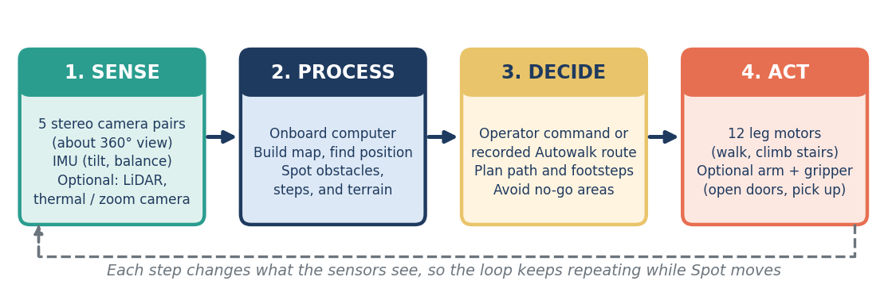

Safety Concerns
1. Sensor limits cause collisions and falls: the depth cameras have a short range and gaps near the hips. Glass, mirrors, very bright surfaces, and thin or low objects can confuse them. Boston Dynamics warns that Spot can still collide with things even with obstacle detection on.
2. Human interaction risks: the joints can pinch fingers, hair, and loose clothing while the motors are on, and a fall or collision could hurt a bystander.

Mitigations
- Distance and training: keep everyone at least 2 meters away and use Spot only in areas limited to trained staff.
- Lockout and stop: lock out the motors or power off before handling, and keep an emergency stop within reach.
- Route and speed limits: mark no-go zones, set speed limits, and avoid glass, elevators, and slippery floors.
- Self-righting: if Spot falls, it can stand back up, which limits damage and downtime.
- Redundancy: add LiDAR or other payload sensors so the cameras are not the only source of obstacle data.

Sources: Boston Dynamics Spot specifications, Spot User Guide, and developer documentation (bostondynamics.com).

